
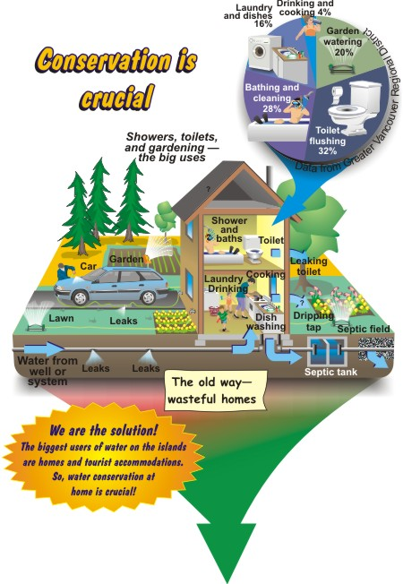
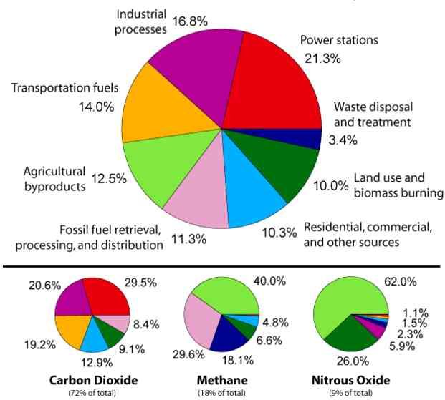
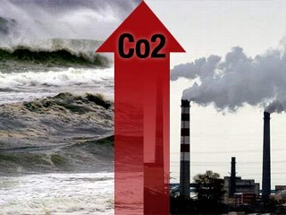
Solutions
Many possible solutions have been proposed to stave off global warming, should it actually be occurring. Some are very practical, while others are grandiose, to say the least. What is certain is that as the world's population continues to grow and developing nations develop, the world's need for space and energy will continue to grow. The need for space will accelerate deforestation. The need for energy will almost certainly increase the rate of fossil fuel burning. Listed below are a number of proposed "solutions" to combat global warming.
The simplest solution is an old one: conservation. Each gallon of gasoline releases 8.64 kg of CO₂ into the atmosphere (source USEPA). Each kilowatt of electricity generated by a coal-fired plant produces about 1.4 kg of CO₂ (source USEPA). Use less = emit less. The USEPA estimates that energy-saving appliance standards in the U.S. will have reduced national electricity consumption by 3% by the year 2000. This reduction will offset the need for 31 large power plants. A 625 MW coal-fired plant (serves about 425,000 homes) emits 1 million tons of carbon each year. The best part about conservation is it also saves you money. Again, the USEPA estimates that consumers will save more than $140 billion by the year 2030 with energy-saving appliances.
Plant a tree. Forests cover 10 billion acres worldwide and sequester 1 trillion tons of carbon. The IPCC estimates that 850 million acres could be made available for planting trees. These trees would take up 60 to 90 billion tons of carbon by the year 2050. Unfortunately, this is only 12 to 15% of projected emissions during this period. Moreover, trees mature and stop rapidly consuming carbon. They are cut down, burned, or decay, which releases their stored CO₂. So trees are a temporary partial solution at best. However, if these trees were used for lumber or paper products, their carbon would be stored for much longer periods of time. This might give the next solution time to work.
The oceans. The oceans already hold 36 trillion tons of carbon and absorb an additional 10 GtC from the ocean surface components each year (see Carbon Cycle). The ocean surface currently absorbs 2.5 GtC from the atmosphere, or roughly 40% of anthropogenic emissions. Given time, the oceans will probably absorb human-induced emissions, just not as fast as we are currently producing them. Proposals have been made to pump power plant emissions directly into the deep ocean. It would probably work, but would be extremely expensive.
John Martin, a scientist at Moss Landing Marine Laboratories in California, proposed in 1986 that we seed the oceans with iron to cause phytoplankton blooms. Such blooms would consume huge quantities of CO₂, and when the plankton die in a couple of weeks they would sink to the bottom and thus sequester their CO₂. Two small trial experiments have shown that it might work. The environmental impact on other creatures in the ocean has yet to be assessed.
Human fat is 76% carbon. What if all 6.5 billion humans gained a kilogram of fat? This would sequester 4.7 MtC, which is only 0.077% of the yearly emissions from anthropogenic sources. Not worth it. On the other hand, you're not contributing much to global warming when you lose weight.
Reduce the amount of incoming solar radiation. There are several ways to do this. Increase cloud cover. Shoot sulfur into the stratosphere like volcanic eruptions do. The National Academy of Sciences estimates it would cost the U.S. about $250 to $500 million a year to offset its emissions this way. This is ironic, since we limit power plant emissions of sulfur into the troposphere. Routinely send a trillion Mylar balloons into the upper atmosphere to reflect sunlight away. Unfurl a 1200 mile long thin shield, 930,000 miles from Earth to reflect solar radiation. This would reflect 2% of the sun's energy. To reduce costs, the shield would need to be manufactured on the moon.
To counter sea level rises, add snow to the east Antarctic ice sheet. The 3 trillion tons of sea water needed each year would be sprayed out as snow on the ice cap, using technology much like ski slopes use to make artificial snow.
Stop burning fossil fuels to generate electricity. Alternatives: Solar cells, hydropower, wind power, nuclear power. Drawbacks: Solar cells are not yet practical or cost efficient. Will not work in high latitudes or cloudy areas where sunlight is not steady or intense. Hydropower is a regional solution. The question must be, Do we want to dam every beautiful river to generate electricity? Wind power is also a regional solution of limited capacity. Conventional nuclear power (based on fission) has fallen out of favor in the U.S. because the spent fuel rods are highly radiactive and must be stored for several million years before they are safe. Also, there is only a limited supply of uranium for use in nuclear reactors. A possible solution is nuclear fusion. This is the process which powers the sun. The technological problems for practical nuclear fusion power are enormous. However, fusion is a relatively clean (spent materials would need to be stored for less than 100 years) and there is a nearly limitless supply of fuel in the world's oceans. Because of the technological problems, the U.S. is lagging far behind the rest of the world in developing fusion power.

What Causes Global Warming?
What are the causes of Global Warming? What is the Green House effect? Is it really that destructive? Read on for information on Global Warming Causes.
Enlarge Image
Global Warming is a major issue due to the industrialization and progress by humankind since the past few years. There has been a hue and cry about Global Warming ever since the idea was first put forward. There are many articles on Global Warming on the internet as well print media which give further details about the causes of Global Warming. Here is some further information on global warming.
Global warming has been and is being caused due to a various number of factors. Global warming is basically a change in the climatic conditions of the earth. These climatic conditions vary due to various reasons, external and internal. Changes to climatic conditions and therefore Global Warming can be caused to natural or man-made circumstances also. Some of the factors causing global warming are volcanic emissions and solar activity.
According to the solar variation theory, the sun has been gaining strength and is at its strongest since a sixty years. Therefore, it may now be acting as a cause of global warming. Sunspots are also said to be a cause or catalyst for Global Warming. Recent reports suggest that the number of sunspots in an area directly affects the amount of time the nearby earth takes to cool. The sun is the main source of energy to the earth. The earth absorbs about seventy percent of the earth's solar flux. This solar flux increases the temperature of the earth's atmosphere, land and oceans.
Orbital forcing is also said to be one of the natural causes of Global Warming. The reports show the effect of the slow tilting of the earth's axis on the climate of the earth. The greenhouse effect is said to be the most important factor regarding global warming. When infrared radiation from the atmosphere increases the temperature of the earth's surface, it is termed as the greenhouse effect. The greenhouse effect has increased the earth's temperature by about twenty four percent.
Carbon dioxide contributes about twelve percent of the greenhouse effect, while water vapor contributes thirty six percent of the greenhouse effect. Methane causes five to ten percent of Global Warming, while Ozone makes around three to seven percent of the greenhouse effect possible.
Solar variation is said to be another reason of Global Warming. The changes in the amount of radiant energy emitted by the Sun are known as solar variation. This solar variation has been correlated with the changes in the Earth's climate and temperature.
Along with the natural causes of Global Warming, scientists have also contributed rapid industrialization to the increase of Global Warming today. Humans had first affected global warming some eight thousand years ago, with the start of agriculture. Due to the clearing of the forests for agriculture, the amount of carbon dioxide in the atmosphere increased drastically.
Scientists are of the opinion that industrialization releases various gases like carbon-dioxide and methane which are known to contribute to Global Warming. Deforestation is also said to increase global warming. Trees contain a high level of carbon, and therefore their cutting creates an increase of carbon in the atmosphere. Humankind also contributes to the increase of carbon dioxide by the burning of fossil fuels. The contribution of humankind to global warming due to the burning of fossil fuels has increased by about eighty percent in the past twenty years.
If the greenhouse effect didn't exist, the temperature of the earth would be around twenty seven Celsius less. Some scientists are of the opinion that human life would be impossible on planet earth if the temperature would be so less.

The Most Significant Cause
The buildup of carbon dioxide in the atmosphere, mainly from your fossil, is the most significant human cause of global warming. Carbon dioxide is released every you burn something, be it a car, airplane or coal plant. This means you must burn less fossil fuel if you want the Earth's climate to remain stable! And unfortunately, we are currently destroying some of the best known mechanisms for storing those carbon-- plants.
Deforestation increases the severity of global warming as well. Carbon dioxide is released from the human conversion of forests and grasslands into farmland and cities. All living plants store carbon. When those plants die and decay, carbon dioxide is released back into the atmosphere. As forests and grasslands are cleared for your use, enormous amounts of stored carbon enter the atmosphere.
An unstoppable feedback loop may happen if you let this continue. If the activities mentioned above warm the Earth just enough, it could cause natural carbon sinks to fail. A "carbon sink" is a natural system that stores carbon over thousands of years. Such sinks include peat bogs and the arctic tundra. But if these sinks destabilize, that carbon will be released, possibly causing an unstoppable and catastrophic warming of the Earth.
The oceans are no longer able to store carbon as they have in the past. The ocean is a huge carbon sink, holding about 50 times as much carbon as the atmosphere.[1] But now scientists are realizing that the increased thermal stratification of the oceans has caused substantial reductions in levels of phytoplankton, which store CO2.[2] Increased atmospheric carbon is also causing an acidification of the ocean, since carbon dioxide forms carbonic acid when it reacts with water. The tiny plants of the ocean, the very bottom of that vast watery food chain, are suffering from the effects of global warming, which means they are becoming less able to store carbon, further contributing to climate change.[3]
As carbon sinks fail, the amount of carbon in the atmosphere climbs![4]

Each year from 1998 through 2007 ranks among the top 25 warmest years on record for the United States, according to the National Oceanic and Atmospheric Administration. Scientists say that the earth could warm by an additional 7.2 degrees Fahrenheit during the 21st century if we fail to reduce emissions from burning fossil fuels, such as coal and oil. This rise in average temperature will have far-reaching effects on the earth's climate patterns and on all living things. Many of these changes have already begun.

Hot, dry weather led to a record-setting 2006 wildland fire season with close to 100,000 fires reported and nearly 10 million acres burned, 125 percent above the decade's average.
» More on how global warming affects weather patterns.

In July 2006, severe heat waves in North America contributed to the deaths of at least 225 people.
» More on how global warming affects our health.

In 2005, scientists reported that some polar bears are drowning because they have to swim longer distances to reach ice floes - they're now being considered for listing under the Endangered Species Act.
» More on how global warming affects wildlife.

At the current rate of retreat, all of the glaciers in Glacier National Park will be gone by 2070.

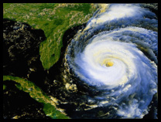
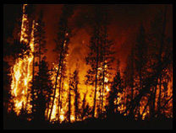
More Powerful and Dangerous Hurricanes
Warmer water in the oceans pumps more energy into tropical storms, making them stronger and potentially more destructive.

Warning signs today:
- The number of category 4 and 5 storms has greatly increased over the past 35 years, along with ocean temperature.
- The 2005 Atlantic hurricane season was the most active Atlantic hurricane season in recorded history, with a record 27 named storms, of which 15 became hurricanes. Seven of the hurricanes strengthened into major storms, five became Category 4 hurricanes and a record four reached Category 5 strength.
- Hurricane Katrina of August 2005 was the costliest and one of the deadliest hurricanes in U.S. history.

Drought and Wildfire
Warmer temperatures could increase the probability of drought. Greater evaporation, particularly during summer and fall, could exacerbate drought conditions and increase the risk of wildfires.

Warning signs today:
- The 1999-2002 national drought was one of the three most extensive droughts in the last 40 years.
- Warming may have lead to the increased drought frequency that the West has experienced over the last 30 years.
- The 2006 wildland fire season set new records in both the number of reported fires as well as acres burned. Close to 100,000 fires were reported and nearly 10 million acres burned, 125 percent above the 10-year average.
- Firefighting expenditures have consistently totaled upwards of $1 billion per year.

Deadly Heat Waves
More frequent and severe heat waves will result in a greater number of heat-related deaths.

Warning signs today:
- In 2003, extreme heat waves claimed as many as 70,000 lives in Europe. In France alone, nearly 15,000 people died during two weeks of soaring temperatures, which reached as high as 104 degrees Fahrenheit.

- Much of North America experienced a severe heat wave in July 2006, which contributed to the deaths of over 140 people, including some who owned working air conditioners.
- In the 1995 Chicago heat wave, 739 heat-related deaths occurred in a one-week period.

Bad Air, Allergy and Asthma
Global warming could increase smog pollution in some areas and intensify pollen allergies and asthma. Hotter conditions could also aggravate local air quality problems, already afflicting more than 100 million Americans.

Warning signs today:
- Scientific studies show that a higher level of carbon dioxide spurs an increase in the growth of weeds such as ragweed, whose pollen triggers allergies and exacerbates asthma.
- The number of pollen allergy and asthma sufferers has increased worldwide over the last several decades. Some researchers have suggested that this could be an early health effect of human-caused climate change.
- Air pollution makes allergies worse: Diesel exhaust particles can interact with pollen and deliver it deeper into the lung.
- Rising temperatures increase ground-level ozone smog production, which presents a serious threat to asthmatics.

Ecosystem Shifts and Species Die-Off
Increasing global temperatures are expected to disrupt ecosystems, pushing to extinction those species that cannot adapt. The first comprehensive assessment of the extinction risk from global warming found that more than 1 million species could be obliterated by 2050 if the current trajectory continues.

Warning signs today:
- A recent study of nearly 2,000 species of plants and animals discovered movement toward the poles at an average rate of 3.8 miles per decade. Similarly, the study found species in alpine areas to be moving vertically at a rate of 20 feet per decade in the second half of the 20th century.
- The latest Intergovernmental Panel on Climate Change report found that approximately 20 to 30 percent of plant and animal species assessed so far are likely to be at increased risk of extinction if global average temperature increases by more than 2.7 to 4.5 degrees Fahrenheit.
- Some polar bears are drowning because they have to swim longer distances to reach ice floes. The U. S. Geological Survey has predicted that two-thirds of the world's polar bear sub-populations will be extinct by mid-century due to melting of the Arctic ice cap.

- In Washington's Olympic Mountains, sub-alpine forest has invaded higher elevation alpine meadows. Bermuda's mangrove forests are disappearing.

Melting Glaciers, Early Ice Thaw
Rising global temperatures will speed the melting of glaciers and ice caps and cause early ice thaw on rivers and lakes.

Warning signs today:
- After existing for many millennia, the northern section of the Larsen B ice shelf in Antarctica -- a section larger than the state of Rhode Island -- collapsed between January and March 2002, disintegrating at a rate that astonished scientists. Since 1995, the ice shelf's area has shrunk by 40 percent.
- According to NASA, the polar ice cap is now melting at the alarming rate of nine percent per decade. Arctic ice thickness has decreased 40 percent since the 1960s.
- Arctic sea ice extent set an all-time record low in September 2007, with almost half a million square miles less ice than the previous record set in September 2005, according to the National Snow and Ice Data Center. Over the past 3 decades, more than a million square miles of perennial sea ice -- an area the size of Norway, Denmark and Sweden combined -- has disappeared.
- Multiple climate models indicate that sea ice will increasingly retreat as the earth warms. Scientists at the U.S. Center for Atmospheric Research predict that if the current rate of global warming continues, the Arctic could be ice-free in the summer by 2040.
- At the current rate of retreat, all of the glaciers in Glacier National Park will be gone by 2070.

Sea-Level Rise
Current rates of sea-level rise are expected to increase as a result both of thermal expansion of the oceans and melting of most mountain glaciers and partial melting of the West Antarctic and Greenland ice caps. Consequences include loss of coastal wetlands and barrier islands, and a greater risk of flooding in coastal communities. Low-lying areas, such as the coastal region along the Gulf of Mexico and estuaries like the Chesapeake Bay, are especially vulnerable.

Warning signs today:
- Global sea level has already risen by 4 to 8 inches in the past century, and the pace of sea level rise appears to be accelerating. The Intergovernmental Panel on Climate Change predicts that sea levels could rise 10 to 23 inches by 2100, but in recent years sea levels have been rising faster than the upper end of the range predicted.
- In the 1990s, the Greenland ice mass remained stable, but the ice sheet has increasingly declined in recent years. This melting currently contributes an estimated one-hundredth of an inch per year to global sea level rise.
- Greenland holds 10 percent of the total global ice mass. If it melts, sea levels could increase by up to 21 feet.

Intense Rainstorms
Warmer temperatures increase the energy of the climatic system and can lead to heavier rainfall in some areas.
Warning signs today:
- National annual precipitation has increased between 5 and 10 percent since the early 20th century, largely the result of heavy downpours.
- The Intergovernmental Panel on Climate Change reports that intense rain events have increased in frequency during the last 50 years and human-induced global warming most likely contributed to the trend.
- According to the National Oceanic and Atmospheric Administration, the Northeast region had its wettest summer on record in 2006, exceeding the previous record by more than 1 inch.



